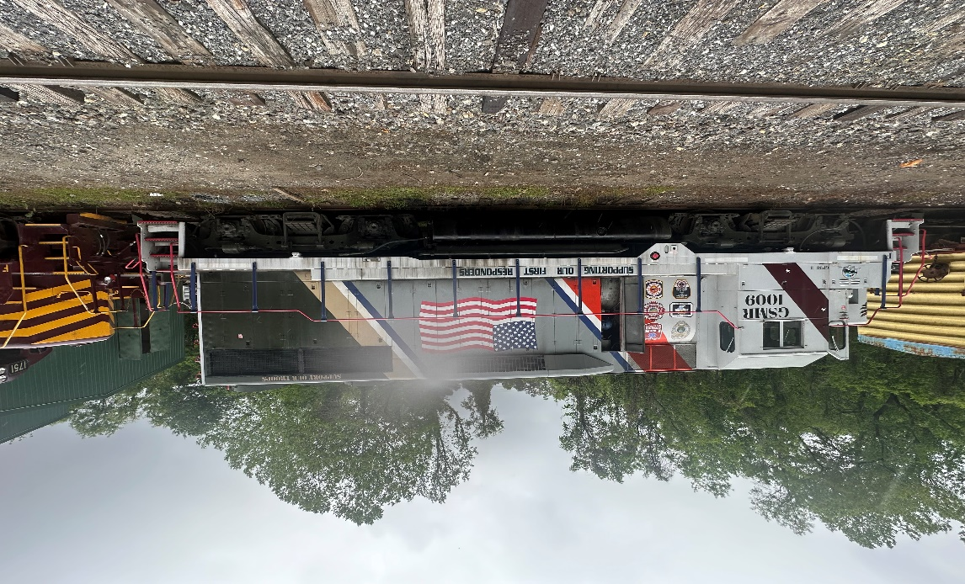

- GP 35 Upgraded to a GP38-3 (N-Force System)
- D32 Main Generator
- 567D3A Engine Block
- D77 Traction Motors (Tig Armatures)
- New UTEX Roots Blowers (Right & Left)
- 645 Power Assemblies
- New Remanufactured Air Compressor
- New Wheels
- New UTEX Fuel Injectors
- New Hot Start Water Heater (240 volt Type)
- New Remanufactured SCR
- New Partial Low Voltage Re-Wire
- Dynamic Brakes
- 62:15 Gear Ratio
- Dual Clasp Brakes
- Locomotive is FRA Blue Carded
- 26L Air Brake System
- Good Body & Paint
- Currently Stored Serviceable
- This Locomotive can be seen running for inspection
- Strong Pulling Locomotive

