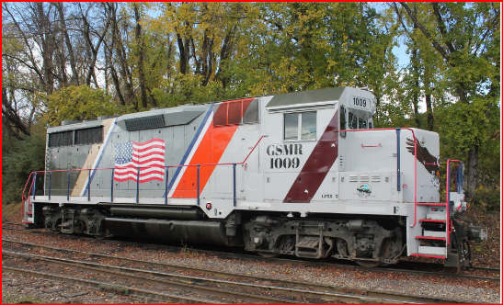

**GSMR 1009**

1. EMD GP35 upgraded to -3 excitation (N-Force)
2. Excellent Puller
3. New Wheels
4. D77 Traction Motors (Tig Armatures)
5. 62:15 Gear Ratio
6. Dual-clasp brakes
7. D32 Main Generator
8. 567D3A engine block
9. Upgraded to Roots Blowers and 645 Power Assemblies
10. Dynamic brakes
11. Fresh Remanufactured Air Compressor
12. Locomotive is FRA Blue Carded
13. 26L Airbrake currently in date
14. Currently stored Serviceable.
15. Good Paint
16. Can be seen running for inspection.

GSMR 1009 has become surplus to our fleet of locomotives. The unit is being sold as-is, where-is, with no warranty written or implied. The locomotive is currently at the GSMR shop facility in Dillsboro, NC. Prior arrangements must be made to inspect the locomotive, which also can be seen in running order by request. Shipping of the locomotive is the buyer’s responsibility. Delivery to interchange with the Blue Ridge Southern Railroad in Sylva, NC is free.

Asking Price of $ is Negotiable.

