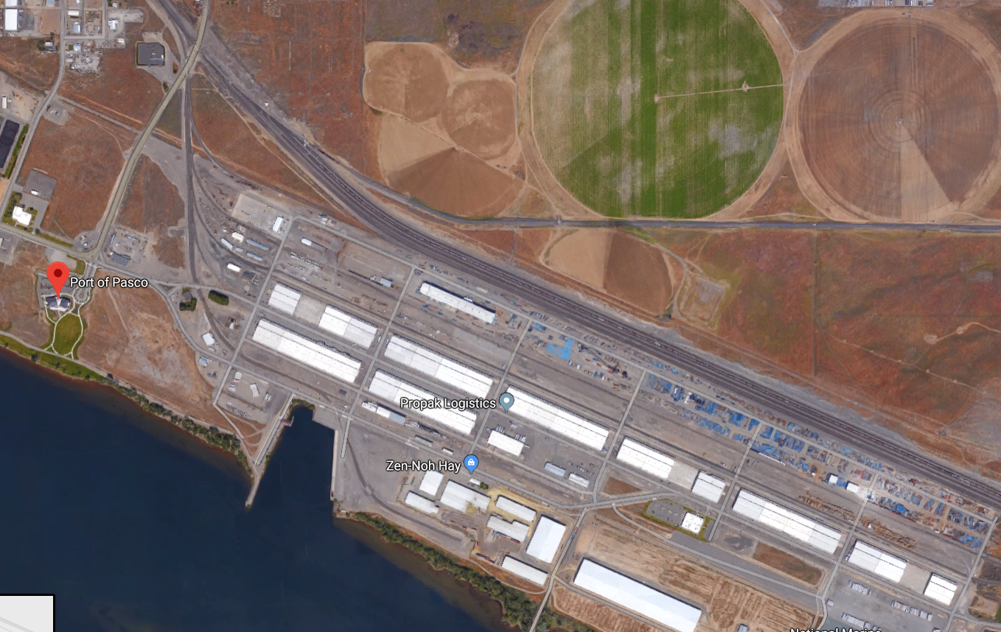

**SE Road 30**

**East Ainsworth ST**

**South Oregon Ave**

**EAST A STREET**