**SEABOARD COAST LINE No. 765348**

**10S-1DR-2C SLEEPER**

Builder: Pullman

Service Date November 30, 1917

Lot: 4996

Plan No. 2585D

Moffett Plan No. 2585D

Vassar College Plan No.4042 Rebuilt December, 13, 1934

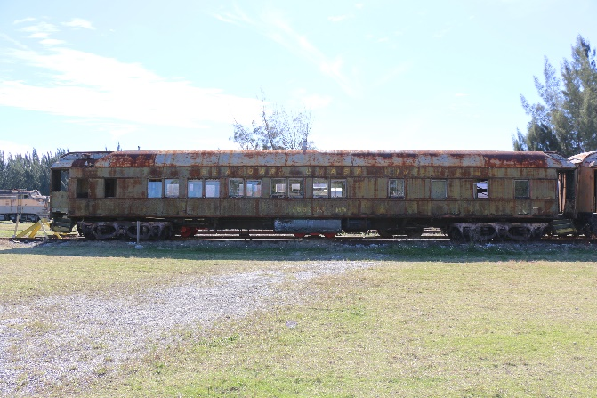A sister car to No. 765310, also an open sleeper, was built by Pullman in 1926 for the Seaboard Air Line as a 10-section, 1-drawing room, 2-compartment sleeping car. The original name of the car is also not sure, it is presumed to be “Vassar College." These two are among the last of their kind and hopefully one if not both will be restored one day.

Status: Stored. Un-restored, Not Open To The Public