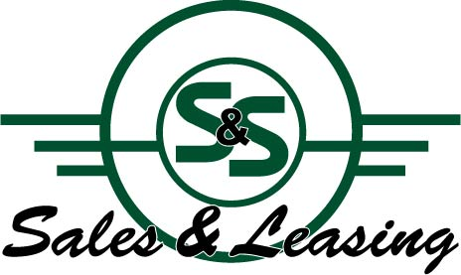

***Po Box 604***

***Farmington, UT 84025***

***(801) 451-2796***

**Offer to Purchase**

March 12, 2021

Ozark Mountain Railcar

Attn; John Suscheck

PO Box 167

Kirbyville MO 65679

John

S&S Sales and Leasing does hereby submit a proposal to purchase the following locomotives:

GP40-2 Unit 3002

GP40-2 Unit 3003

**For a purchase price of ONE HUNDRED FIFTY THOUSAND USD ($150,000 USD) each locomotive. For a total purchase price of THREE HUNDRED THOUSAND USD ($300,000. USD)**

Our offer is contingent on the following:

1. Based on inspection
2. Inspection will be within 14 days of acceptance of offer to purchase
3. Terms of this contract will not be disclosed to anyone outside of this agreement without the express written consent of S&S Sales and Leasing.
4. Locomotives will be provided free and clear of any liens or encumbrances
5. No storage fees will be charged to S&S.
6. S&S or assigned agents may work onsite to prepare locomotive for movement or dismantle at S&S sole discretion.

ACCEPTED BY:

John Suscheck Date

Ozark Mountain Railcar